Error controllingCoding Techniques

1.2 Optical Communication System Model:
The optical communication system model is depicted in figure 1.1. The information source
generates a sequence of binary bits. For the Reed-Solomon encoder these binary bits are
grouped to form q-ary symbols from GF (q=2m) (refer sections 3.3, 4.1 and 5.2). These
symbols2 (bits) in turn are grouped into blocks of k symbols denoted by u = ( 1 2 k u , u ,K,u )
the message block. The channel encoder adds controlled amount of redundant symbols to
each of the k symbol message blocks to form code word blocks of n symbols denoted by
v = ( 1 2 n v , v ,K, v ).
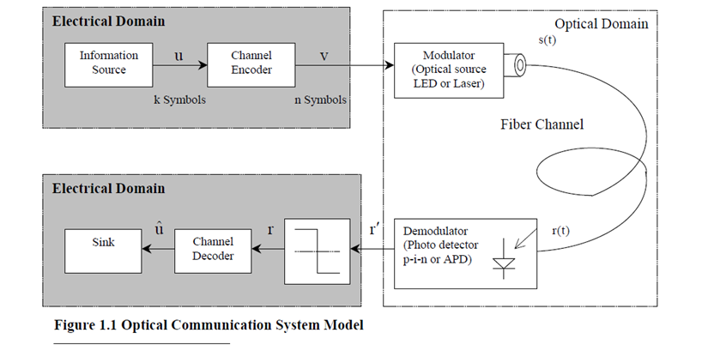
In our work, we have used a digital transmission scheme in which an electrical bit stream modulates the intensity of the optical carrier (modulated signal). The modulated signal is detected directly by a photo detector to convert it to the original digital (modulating) signal in the electrical domain. It is referred to as Intensity Modulation with Direct detection (IM/DD) or On-Off Keying (OOK) or Amplitude Shift Keying (ASK). When the RS encoder is used, the q-ary symbols have to be translated into a sequence of log2(q) binary bits before driving the optical source. The output of the modulator is an optical pulse of duration T for bit 1 and no pulse for bit 0. Thus a signal waveform s (t) i of duration T is transmitted over the fiber optic channel such that 0 ;i 0 ,s (t) A ;i 1 I = = 1.3 where A is the amplitude of the transmitted optical pulse A mathematical model for the optical channel is the AWGN channel which models Gaussian (thermal) noise present at the receiver’s front-end electronic circuitry. In the model, a Gaussian random noise process n(t) is added to the transmitted signal waveforms(t) [14]. We have introduced the AWGN channel model in section 4.2, which is a vector representation where v represents the transmitted code word, e represents the white noise process and the corrupted received word is represented as r′ . At the receiver, the demodulator is a photo detector (p-i-n or APD), which converts the received optical signal r(t) into electrical current I (t)(refer section 6.3). The vector r′ in the model is obtained as the output of the demodulator. The vector r′ contains sufficient statistics for the detection of the transmitted symbols [14]. A sequence of vector r′ is then fed to the decoder, which attempts to reconstruct the original message block uˆ , using the redundant symbols. In many situations, the vector r′ is passed through the threshold detector, which provides the decoder a vector r with only binary zeros and ones. In such a case the decoder is said to perform hard decision decoding and the resulting channel consisting of the modulator, AWGN channel, demodulator and detector is called the Binary Symmetric Channel (refer section 4.2) [14]. The AWGN and BSC channel models are used throughout the report for our analysis.
The Optical Fiber Channel
In order to get a broad and basic understanding of the principles and operation of optical
communication systems, we review the different types of optical fiber; discuss the effects of
channel impairments in section 2.1 and techniques to compensate for channel impairments in
section 2.2. The fiber mode, in a crude way, can be described as one of the various possible
patterns of propagating electromagnetic field through the fiber. A single-mode fiber supports
long-distance signal transmission of a single ray or fundamental mode of light at a particular
wavelength (λ) . Multimode fibers, on the other hand, allow multiple light rays concurrently
each at a slightly different reflection angle within the optical fiber core.
Channel Impairments
We will discuss fiber channel impairments in terms of dispersion, attenuation and noise in
general, and nonlinear effects and inter-channel cross talk particularly in WDM systems.
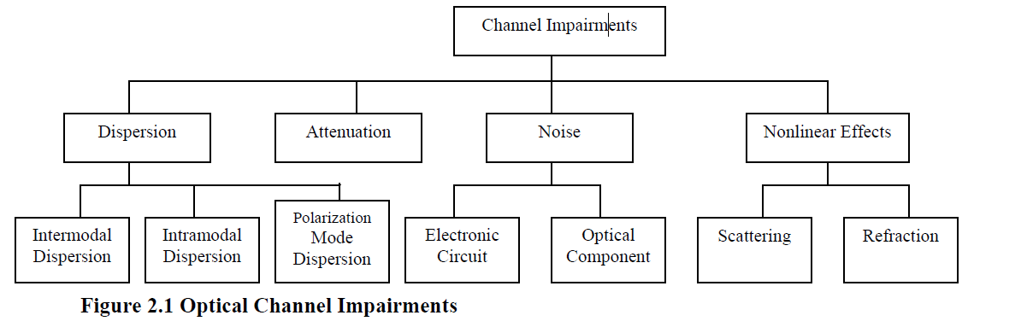
Noise
Factors contributing to the degradation in signal-to-noise ratio (SNR) at the receiver in optical
fiber are due to impairments introduced by a combination of electronic circuits, optical
components such as add/drop multiplexers, optical cross-connects and fiber optics. Electronic
interface circuits introduce timing jitter occurring due to fluctuations in sampling time from
bit to bit, shot noise due to random fluctuations of charge carriers and thermal noise due to
random thermal motion of electrons in the photo detector.
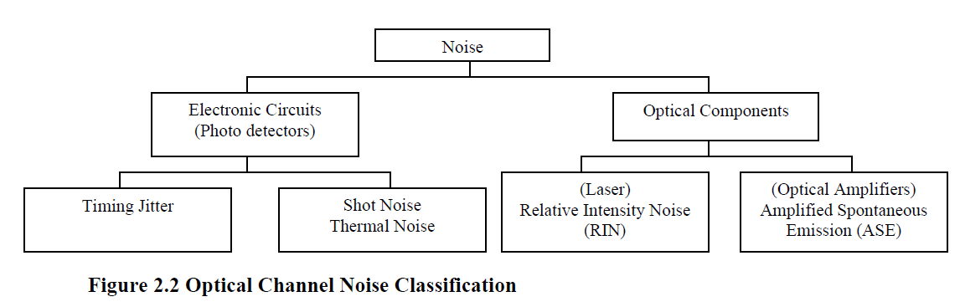
Optical components– lasers introduce fluctuations in transmitted power and optical amplifiers
introduce amplified spontaneous emission (ASE) noise, which has constant spectral density
(white noise) [1]. Both shot and thermal noise have approximately Gaussian statistics [1] such
That (t) i (t) i (t) I = Ip + s + T 2.1
whereI (t) : photodiode current generated in response to an optical signal Ip : the average currenti (t) s : current fluctuation related to shot noisei (t) T : current fluctuation induced by thermal noise
2.1.2 Dispersion
Dispersion in the fiber-optic systems causes the optical pulses to broaden in time as they
travel through the fiber, thus giving rise to intersymbol interference (ISI). The effect of ISI is
severe at high transmission rates and increased link lengths [18]. Dispersion in optical fibers
can be classified broadly as Intermodal (multipath or differential mode) dispersion,
Intramodal (group-velocity or chromatic) dispersion and Polarization Mode dispersion
(PMD). Intermodal dispersion (between rays or modes) occurs in multimode fibers, where
different rays travel along paths of different lengths resulting in spread of the optical pulse at
the output end of the fiber. Using the concept of fiber modes in context with the wave
propagation theory, intermodal dispersion is due to different group velocities associated with
different modes. Intermodal dispersion does not occur in single-mode fibers. Multimode
fibers are not suitable for long-distance communication [1]. Multimode fibers and Intermodal
dispersion are not discussed any further in the report.
Group velocity dispersion (GVD) causes pulse broadening in single-mode fibers within the
fundamental mode, since the group velocity of photons associated with the fundamental mode
is frequency dependent. The optical source does not emit just a single frequency but a band of
frequencies centered around a desired frequency such that the different spectral components
of the transmitted signal have different propagation delays. Consequently, the different
spectral components travel at slightly different speeds resulting in dispersion. GVD depends
upon the transmitted pulse shape, spectral width of the light source and chirp [52]. Broad
spectral width of the light source results in a range of wavelengths separated infinitesimally.
Thus, signals with high data rate and broad spectral width are distorted by GVD. A
transmitted pulse is said to be chirped if its carrier frequency changes with time [1]. Lasers
generally generate pulses that are chirped. The spectrum of a chirped pulse is broader than
that of the unchirped pulse. In short, broadening of the spectrum accentuate GVD. A singlemode
fiber supports two orthogonal states of polarization for the same fundamental mode
(polarization-division multiplexing PDM). With PDM, two channels at the same wavelength
are transmitted. The orthogonal polarized components of the fundamental mode undergo
birefringence (splitting of a light wave into two unequally reflected waves) due to
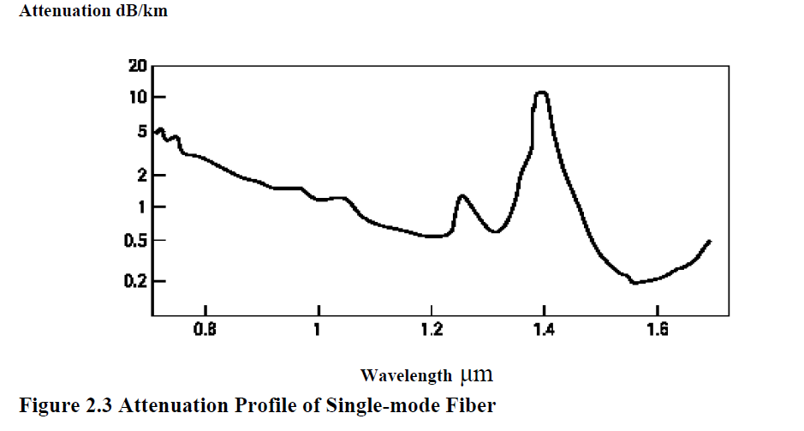

irregularities in the cylindrical symmetry of the core [1]. The resulting pulse broadening is
due to difference in speed of the light waves and called Polarization Mode dispersion (PMD).
Since the birefringence changes with temperature, pressure, stress and other physical
conditions, the impairments due to PMD are time-variant. PMD is proportional to the square
root of the fiber length hence PMD is significant in long-haul communication systems.
Dispersion is typically measured in picoseconds per kilometer. After GVD, PMD is the next
critical bottleneck for higher bit rate transmission systems (10 Gbits/s and above).
α = −(10/Λ) λογ₁₀(π_{ουτ}/π_{ιν})dB/km
Fiber loss depends on the wavelength of transmitted light. First minimum is observed at
around 850 nm, second at 1310 nm and third in the wavelength region near 1550 nm.
Multimode fibers operate in the 850 nm region while 1310 nm wavelength is used both for
single and multimode fibers. Short single-mode fiber links operate at 1310 nm while longdistance
communication is at 1550 nm where the attenuation is the minimum. The 10 Gbits/s
Ethernet operates at both 1310 nm and 1550 nm. WDM divides the optical power among
multiple channels, attenuating them further. Therefore, increasing capacity by adding WDM
channels leads to increased attenuation of optical signal per wavelength and hence decreases
transmission distance. Material absorption and scattering also contribute to fiber losses.
2.1.4 Nonlinear Effects
The fiber channel also introduces nonlinear effects like scattering and Kerr effects, which are
dependent on the intensity of optical power. The refractive index of the fiber core depends
upon the intensity of light at high power levels [1]. The Kerr effects are due to intensity
dependence of the refractive index, such that signals with different intensity levels travel at
different speeds in the fiber.
8
Theeffects are explained below
♦ Self phase modulation (SPM) in which the phase of the signal gets modulated such that
a wavelength can spread out onto an adjacent wavelength.
♦ Cross phase modulation (XPM), whereby several wavelengths in a WDM system can
cause each other to spread out.
♦ Four-wave mixing (FWM) observed in WDM systems in which three signals at different
wavelengths interact with each other to create a fourth signal at a new wavelength.
The Kerr Effects account to spectral broadening. In WDM systems, nonlinear effects cause
interference by spreading energy from one wavelength channel into another channel. These
effects can be reduced by transmitting signals at low power levels at the expense of signal-tonoise
ratio and reduced link lengths.
2.1.5 Inter-channel Cross talk
Linear cross talk occurs when optical filters and multiplexers often leak a fraction of signal
power from neighboring channels to the photo detector [1]. Such a cross talk is out-of-band
and is less severe because of its incoherent nature. In-band cross talk, also linear, occurs when
a WDM signal is routed by an N*N wave guide-grating router (WGR) [1]. The routing is
based solely on the wavelengths of incoming channels. In-band cross talk is coherent in
nature. In multichannel systems, transfer of power from one channel to another takes place
due to Kerr Effects (refer section 2.1.4). Such a cross talk is nonlinear. Inter-channel cross
talk may be one of the reasons behind burst errors in multichannel fiber-optic communication.
Scattering of light is a loss mechanism in the optical fiber and occurs due to fluctuation in
silica density in the core during fabrication [1]. Two types of scattering effects occur, viz.,
linear and nonlinear scattering. Rayleigh scattering is linear and occurs when the fluctuations
in silica density are smaller than the wavelength of light. Stimulated Raman (SRS) and
Brillouin scattering (SBS) are nonlinear scattering effects due to intensity-dependent
refractive index, which occur only at high optical power levels in single-mode fibers.
Nonlinear scattering alters the frequency of scattered light thus contributing to attenuation for
light transmission. Thus, scattering effects induce loss in transmitted optical power.
We conclude this section stating that, dispersion introduces memory in the signal and limits
the data rate of the signal, which is transmitted over the fiber. Fiber loss imposes a limitation
on the transmission distance. Impairments induced by GVD and attenuation is linear since
both are independent of light intensity. It is interesting to note that, though GVD and
attenuation are linear in nature but they make the fiber channel nonlinear. PMD is time
varying phenomenon and occurs in multichannel transmission using single-mode fibers over
long distances. The optical point-to-point link in Gigabit and 10 Gbits/s Ethernet is relatively
short (less than 80 km) in which case PMD can be ignored and the channel can be treated as
time-invariant. The Kerr effects, SRS and SBS are nonlinear in nature since they are intensity
dependent, occurring at higher power levels in WDM systems.
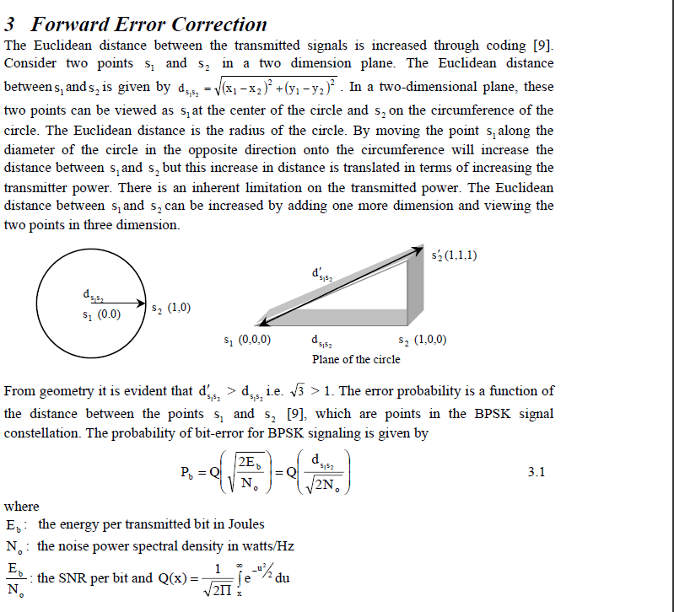

The Q(x) function is a decreasing function of its argument x i.e. the bit-error probability
decreases as the Euclidean distance increases. The reduction in error probability is not
obtained for free but with an increase in bandwidth. Here, it is shown that the Euclidean
distance is increased through adding one more dimension, which in essence is adding
redundancy and the principle behind channel coding. In FEC, the algebraic structure of the
code is used to determine which of the valid code word is most likely to have been
transmitted, given the erroneous received word. We will discuss error detection and correction
in detail in section 4.2. A scheme in which the decoder requests a retransmission of the code
word upon detection of an error in the received word is referred to as automatic repeat
request (ARQ). The focus of our discussion is on FEC so ARQ will not be discussed any
further in the report.
There are two primary system parameters, viz., BER and SNR per bit that determine the
performance of modern optical communication systems. Specifically, data is transmitted by a
sequence of pulses, and the system must ensure that these pulses are received with a
sufficiently low probability of error. Given a particular receiver (photo detector), a minimum
received power is required for achieving a specified BER. An optical fiber introduces
attenuation and dispersion in the system such that, attenuation tends to increase the
transmitted power requirement to meet the desired SNR at the receiver, whereas dispersion
imposes a limitation on the data transmission rate over the fiber. We state the advantages of
FEC in section 3.1 introduce ECC in section 3.2 and give a justification for the use of block
codes for error correction in fiber-optic systems in section 3.3.
3.1 Advantages of Forward Error Correction
The span of an optical link is determined by the optical power budget [1] (refer section 6.3).
To create links with large spans, EDFA or repeaters are used which add to the noise floor of
the system (refer sections 2.1.1 and 2.2). The span can be increased without the use of EDFA
such that using high quality, high cost optical components, increases the transmitted power.
This increases the overall system cost. With the use of FEC, following benefits can be
achieved for a desired link span [46]
♦ Significant gain in the overall optical power budget is achieved.
♦ FEC implementation reduces the transmitted optical power requirement, thus the intensity
dependent impairments (refer section 2.1.4) are reduced automatically.
♦ Relaxation on the high-end specification of the optical components reduces the cost.
♦ Correction of burst errors introduced by inter-channel cross talk in WDM systems.
OR for a specified power budget
♦ The power gain margin can be used to increase the span of the optical link, which
accounts for less number of repeaters and amplifiers.
♦ Use of few repeaters and amplifiers reduces the overall noise floor and improves the SNR,
which pays in terms of lower BER.
♦ In systems implementing ARQ, retransmission results in wastage of bandwidth, which can
be avoided by implementing FEC.
It is quite natural there exist some inherent disadvantages for the advantages gained from a
particular technology. FEC is no exception, since redundancy is introduced in the transmitted
data stream. This imposes a requirement on increased signaling rate, which accounts for
increase in bandwidth requirement. Also, at data rates of 10 Gbits/s and above the
computational complexity and power consumption involved in implementing FEC plays an
important role in system design [18]. There is a trade-off in power efficiency and spectral
efficiency when implementing FEC.

